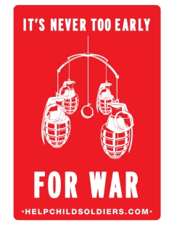
Introduction

http://www.youtube.com/watch?v=KytToTiPU4U&feature=channel Ishmael Beah, a boy from Sierra Leone explains his experience in the army as a child . He is a UNICEF ambassador now.

http://www.youtube.com/watch?v=Bql8U1KmjUU&feature=related

Footage images and videos-rough!

http://www.youtube.com/watch?v=p3OcYVQ9o3o&feature=related

Ishmael reading excerpts o his book “A long way gone: memories..”
The use of children as soldiers in armed conflict is among the most morally repugnant practices in the world, as illustrated by this Los Angeles Times photo essay. Children are combatants in nearly three-quarters of the world's conflicts and have posed difficult dilemmas for the professional armies they confront, including the United States'. Yet moral reasons aside, compelling strategic arguments exist for limiting the use of child soldiers: When conflicts involving children end, experts say the prospects for a lasting peace are hurt by large populations of psychologically scarred, demobilized child soldiers. Parts of Africa, Asia, and South America risk long-term instability as generations of youth are sucked into ongoing wars.
http://www.latimes.com/news/nationworld/world/la-060405uganda-fl,0,1201731.flash a narrated-pictured doc.
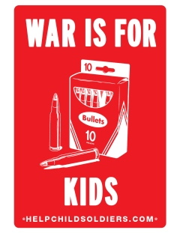

What is a child soldier?
The United Nations Children Fund (UNICEF) defines child soldiers as "any child—boy or girl—under eighteen years of age, who is part of any kind of regular or irregular armed force or armed group in any capacity." This age limit is relatively new, established in 2002 by the Optional Protocol to the Convention on the Rights of the Child. Prior to 2002, the 1949 Geneva Conventions and the 1977 Additional Protocols set fifteen as the minimum age for participation in armed conflict. While some debate exists over varying cultural standards of maturity, nearly 80 percent of conflicts involving child soldiers include combatants below the age of fifteen, with some as young as seven or eight.

How widespread is the use of child soldiers?
Approximately 300,000 children are believed to be fighting today in some thirty conflicts worldwide. Nearly half a million additional children serve in armies not currently at war, such that 40 percent of the world's armed organizations have children in their ranks. Since their ratification of the Optional Protocol, many armies, including that of the United States, adjusted their enlistment policies in compliance with the new regulations.

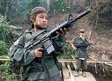
Are child soldiers effective?
Yes. Trusting, vulnerable, and often intimidated, children can easily be manipulated, experts say. In combat, children can be daring and tenacious, particularly when under the influence of drugs—a common practice—or when compelled by political or religious zeal. Child units can greatly add to confusion on battlefields, slowing opposing forces' progress. Children have also been used as scouts, messengers, minesweepers, bomb-makers, and suicide bombers. Child units are also effectively used as advance troops in ambush attacks.

Are girls used as soldiers?
Yes. About 30 percent of armed groups using children include girls. In addition to fighting, girls are often subjected to sexual abuse, and in some cases are taken as sexual slaves by army leaders. Human Rights Watch reports having interviewed girls who got pregnant by their commanders, then forced into combat with their babies strapped to their backs.
http://edition.cnn.com/2005/WORLD/europe/08/23/uk.girl.soldiers/index.html
http://www.youtube.com/watch?v=hNnXGV4KjEw Madeleine’s experience as a soldier-from Congo

Are child soldiers a new phenomenon?
No, they are not. Child combatants have been found and always been presents in war history. Perhaps the most notable example is the Hitler Jugend (Hitler Youth) in the final days of World War II. What is new is the great number of them who can be found on the modern battlefield. Several factors have been the cause of this rise. First, children in modern conflict zones are more easily recruited as the social structures around them deteriorate. This is particularly the case in long, forgotten conflicts and in parts of Africa, where the AIDS epidemic will have created 50 million orphans by now. The majority of child soldiers volunteer, though they often do so because it is their best option for survival. Others enlist to exact revenge after their families are abused or murdered. Second, weapons have been created smaller, lighter, easier to use, and more lethal. A ten-year-old can learn to effectively fire an AK-47 in half an hour. Third, despots and warlords regularly use children as effective, cheap, and expendable fighters.
http://theinspirationroom.com/daily/2009/help-child-soldiers/
