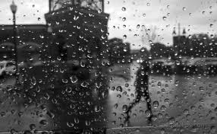
She Work in a diner’s / I meet her –WHEN

The dog follow the kids/ one of them fall down-WHILE

Meg call me/ I study for my exam-WHILE

I wake up this morning/ it rain-WHEN

He break his arm/ he ski-WHILE

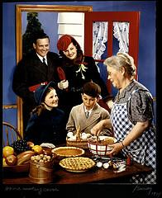
Granny cook dinner/ they arrive-WHEN

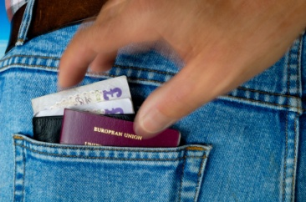
We walk home/ the two men run out of the bank-WHEN

Paul drive home/ he see the accident-WHILE

I look for a new job / I win the lottery.-WHEN

They shop/ a pickpocket stole their wallet-WHILE

